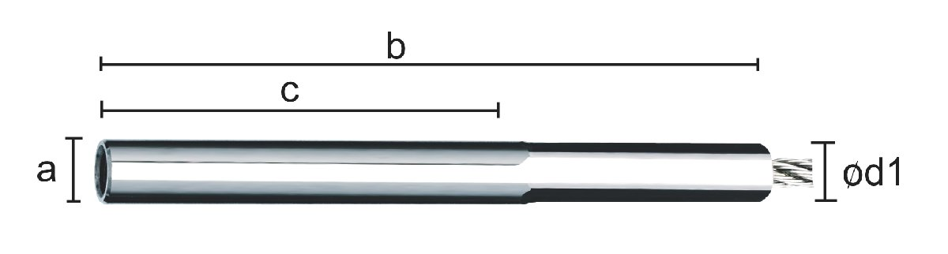
INTERNAL THREAD SWAGE
Part # RH | Part # LH | ø Rope in mm | a | b | c | ød
860-0400-020 | 861-0400-020 | 4 | M6 | 65 | 20 | 8
860-0400-035 | 861-0400-035 | 4 | M6 | 90 | 35 | 8
Breaking strength: 90% of rope Max. Breaking Load
AISI 316 Dimension c for hole depth.

e-mail: sales@decorcable.com
Toll Free: (800) 444-6271
© Copyright 2003 Carl Stahl DécorCable Innovations

